 |  | 
 | 201288865 | 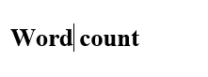
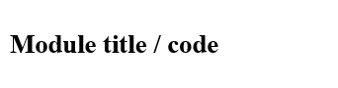 | Programming for Geographical Information Analysts: Core Skills  GEOG5990M01 | 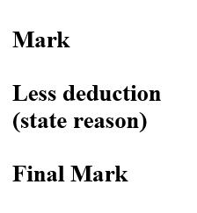
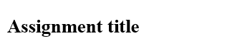 | Assignment 2
 | Dr. Andy Turner

1.
2.
3.

Introduction:

This project aims to help companies to generate a map of the importance of each location in the UK depending on three factors excluded from three maps, the first represents the population distribution, the second displays the geographical importance and the last shows transport network. The weight of each factor can be controlled using a slider, and the resulting map (weighted map) can be saved as a raster file. In the result map the lighter the point, the better the place.

(Site location problem a flow diagram)

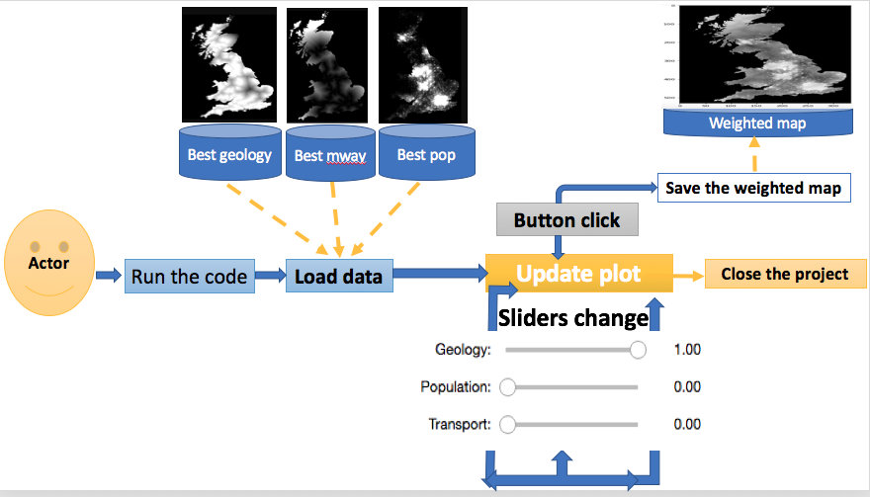

Software development process:

I followed an incremental approach in developing this project, at the beginning I started by loading the three given maps and computed the resulting map with fixed weight parameter for the values coming from each map, I draw the resulting map and make sure I get correctly.
In the second stage, I added the three sliders to control the weights of the values coming from each map in the resulting map. Which makes it mandatory to convert the code computing and drawing the resulting map into a function with three parameters. I test the code by changing each slider and noticing the change in the resulting map.
In the third stage, I added the save button to save the resulting map as a raster file. When I check the result file I discovered it has values greater than 255, so I refactor the code to rescale the values.

The issues during development with solution:

- The issue was that code crashes when the values from the three sliders are 0.0 at the same times.
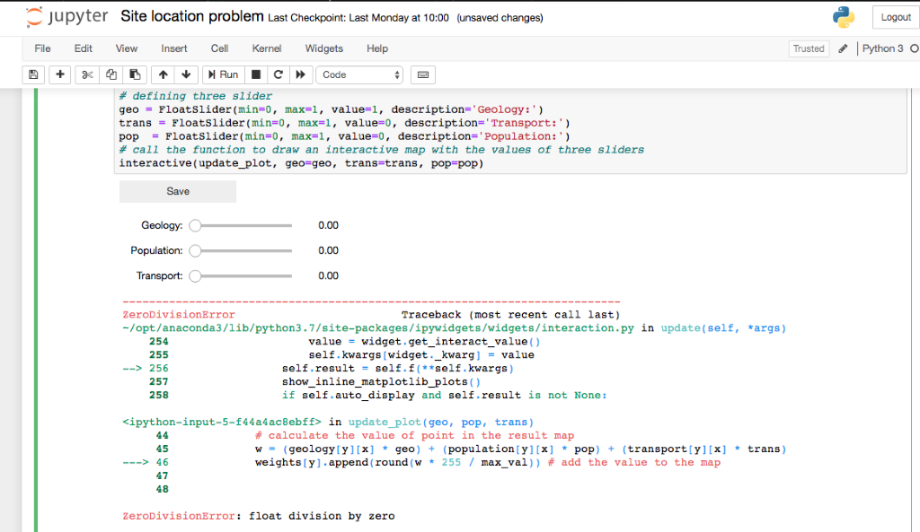

I solved this issue by setting the minimum value of the geology slider to 0.01 as below.
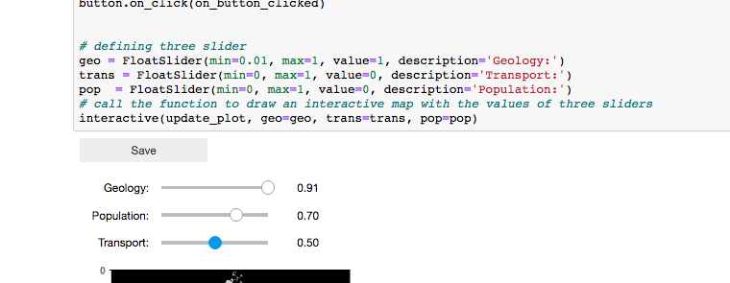

2- another issue was getting values greater than 255 in the result map raster file, which I solved using the equation ‘w * 255 / max_val’, where ‘ w’ is the value of each pixel in the result map and ‘max_val’ is the maximum possible value calculated using the equation ‘max_val = (255 * geo) + (255 * pop) + (255 * trans)’, ‘geo’, ‘pop’, and ‘trans’ are the three weight parameters from the sliders.
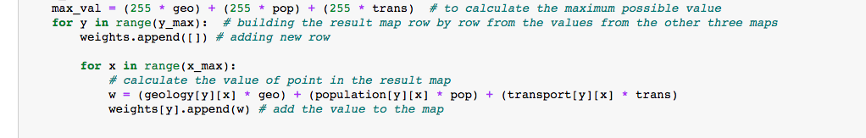
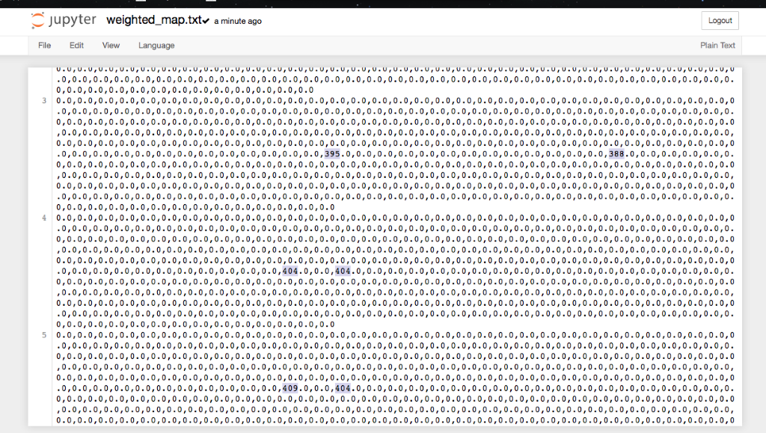

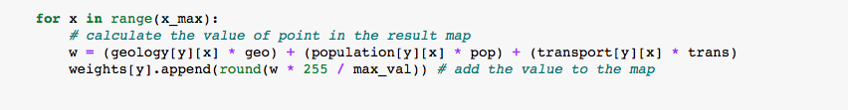

3 – Small issue that I got small size map at the beginning, I searched for a solution which is shown in the code snippet below.

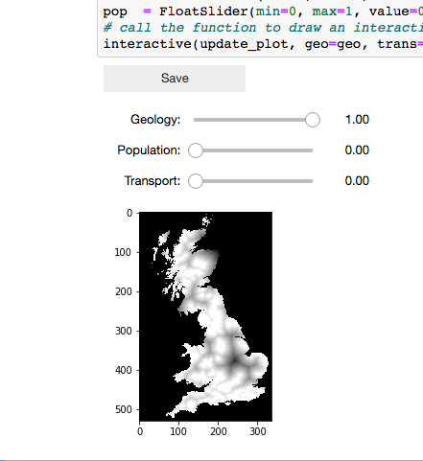

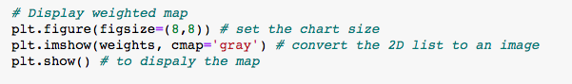

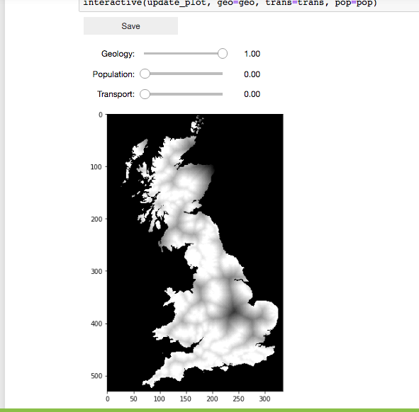
4- The final issue is to show the top 10 percent of the areas in blue and it is yet to be solved.

Conclusion:

To sum up, this project builds a graphical user interface to help who interested to set the best location such as factories, schools and hospitals. In addition, this project used a combination of several maps to produce maps for decision makers. As future plan this project can be converted to a web service where we get the weights of each factors as URL parameters, we may include more maps like government services, and age distribution.

Reference:

(Stack Overflow) 2017. Jupyter Notebook: interactive plot with widgets. [Online]. [Accessed 27 December 2019]. Available from: https://stackoverflow.com/

(Stack Overflow) 2014. IPython notebook interactive function: how to set the slider range. [Online]. [Accessed 30 December 2019]. Available from: https://stackoverflow.com
Penilla, D. 2019. How to create buttons in Jupyter. [Online]. [Accessed 2 January 2020]. Available from: https://medium.com

